DC Reports Needed Clarification

1. EMPLOYEE REPORTS-> 1.1. what does DC Metro Resident represent

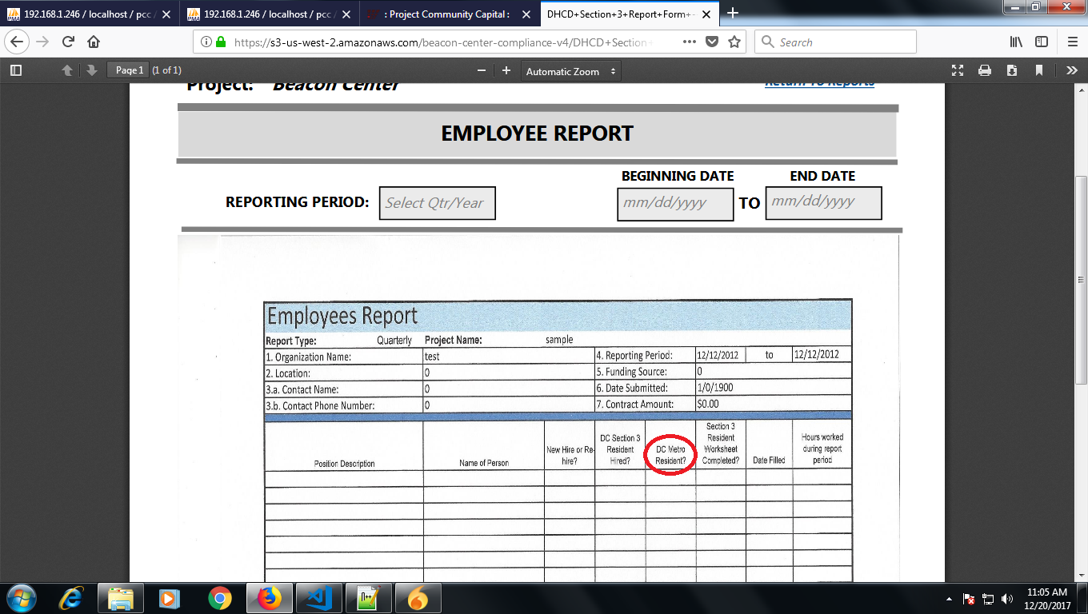

2.CONTRACTS REPORTS ->2.1. what does Sec3 Bussiness Concern represent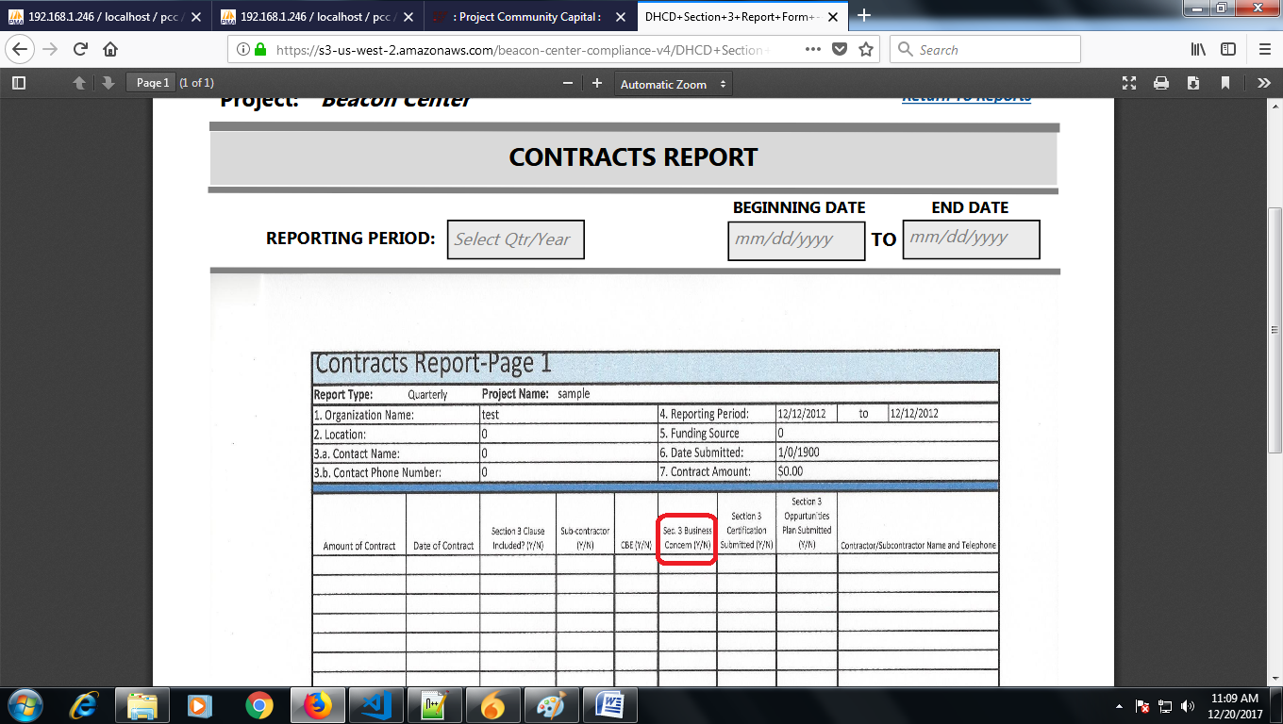

3.DOES EMPLOYEE REPORT->

3.1. what does Agreement represent

3.1. what does DC Quadrant represent

3.1. Why Upload used Here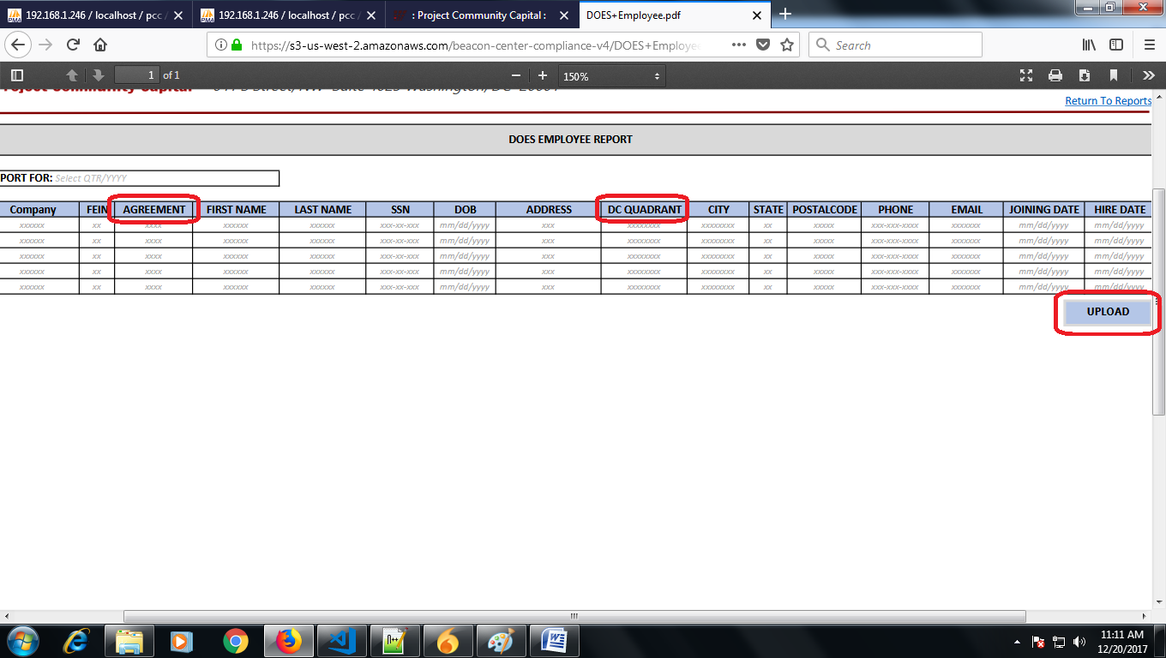

Internal Reports Needed Clarification

1. D.C. RESIDENT AND NEW HIRE REPORT-> 1.1. How and where Goal is assigned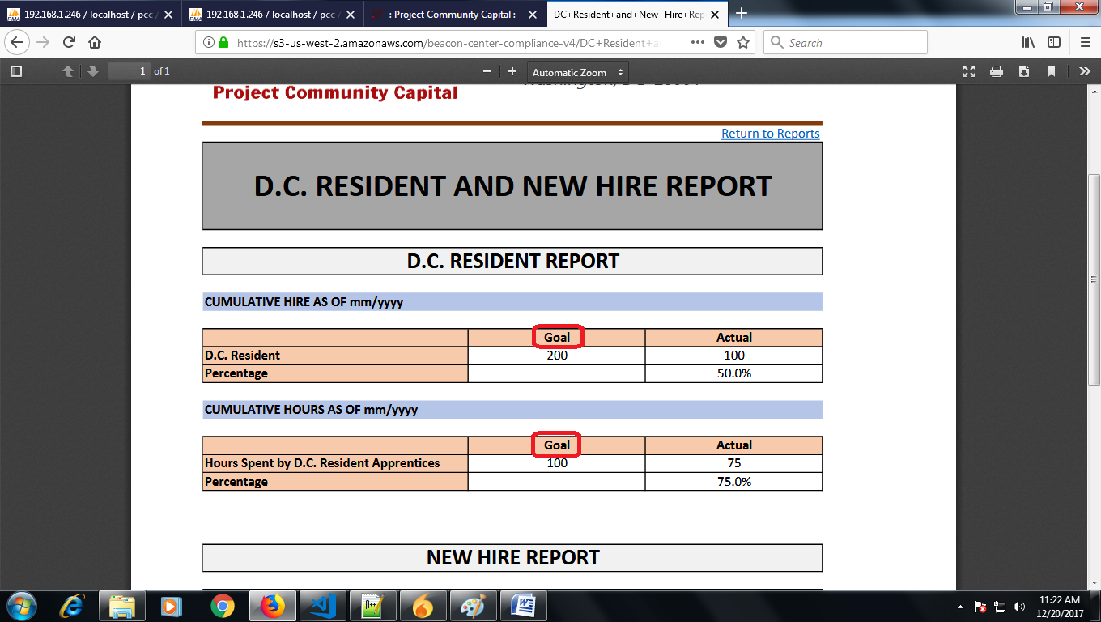
2. Expenditure Report->

2.1. why empty cells and data of date, payment, balance field are filled